**Lab Sheet 2**

* 1. WAP in java to create multiple threads with following technique:
     1. Implementing Runnable

**Source code:**

**package** Lab2;

**class** MyRunnable **implements** Runnable {

@Override

**public** **void** run() {

**for** (**int** i = 1; i <= 5; i++) {

System.***out***.println(Thread.*currentThread*().getId() + " Value " + i);

}

}

}

**public** **class** RunnableExample {

**public** **static** **void** main(String args[]) {

Thread thread1 = **new** Thread(**new** MyRunnable());

Thread thread2 = **new** Thread(**new** MyRunnable());

// Start the threads

thread1.start();

thread2.start();

}

}

**Output:**

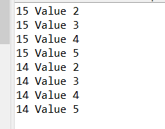

* + 1. Extend Thread class.

**Source code:**

**package** Lab2;

// 1 b

**class** MyThread **extends** Thread {

@Override

**public** **void** run() {

**for** (**int** i = 1; i <= 5; i++) {

System.***out***.println(Thread.*currentThread*().getId() + " Value " + i);

}

}

}

**public** **class** ThreadExample {

**public** **static** **void** main(String args[]) {

// Creating multiple threads by extending Thread class

MyThread thread1 = **new** MyThread();

MyThread thread2 = **new** MyThread();

// Start the threads

thread1.start();

thread2.start();

}

}

**Output:**

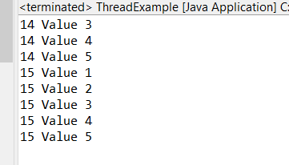

1. WAP to take two numbers as input from user and perform Addition, subtraction, multiplication and division. [Catch the possible exception if any].

**Source code:**

**package** Lab2;

///question 2

**import** java.util.Scanner;

//import java.io.Execption;

**import** java.io.IOException;

**public** **class** Calculation {

**public** **static** **void** main(String[] args) {

// **TODO** Auto-generated method stub

System.***out***.println("Enter number a: ");

**int** a = **new** Scanner(System.***in***).nextInt();

System.***out***.println("Enter number b: ");

**int** b = **new** Scanner(System.***in***).nextInt();

**try** {

**int** add=a+b;

**int** sub=a-b;

**float** div= a/b;

**int** mul= a*b;

System.***out***.println("Add: "+add);

System.***out***.println("Sub"+sub);

System.***out***.println("Div: "+div);

System.***out***.println("Mul"+mul);

}

**catch**(Exception e){

System.***out***.println(e.getMessage());

}

}

}

**Output:**

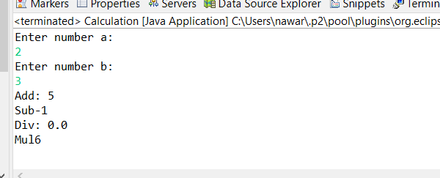

1. WAP to read the content of a file and display it.

**Source code:**

**package** Lab2;

////question 3

**import** java.io.File;

**import** java.io.FileNotFoundException;

**import** java.util.Scanner;

**public** **class** ReadFile {

**public** **static** **void** main(String[] args) **throws** FileNotFoundException {

// **TODO** Auto-generated method stub

String path="C:\\Users\\nawar\\OneDrive\\Documents\\Eclipse_JAVA\\College_Lab_Report\\bin\\Lab2\\filename.txt";

File file= **new** File(path);

Scanner myReader= **new** Scanner(file);

**while** (myReader.hasNextLine()) {

String data = myReader.nextLine();

System.***out***.println(data);

}

}

}

**Output:**

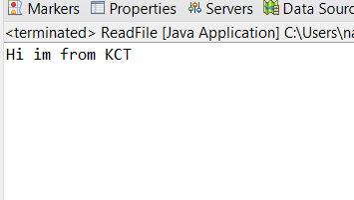

1. WAP to write some content in a file.

**Source code:**

**package** Lab2;

**import** java.io.File;

**import** java.io.FileWriter;

**import** java.io.IOException;

**import** java.util.Scanner;

////question 4

**public** **class** WriteFile {

**public** **static** **void** main(String[] args) **throws** IOException {

// **TODO** Auto-generated method stub

String path="C:\\Users\\nawar\\OneDrive\\Documents\\Eclipse_JAVA\\College_Lab_Report\\bin\\Lab2\\filename2.txt";

File myObj = **new** File(path);

**if**(myObj.createNewFile()) {

System.***out***.println("File created: " + myObj .getName());

}**else** {

System.***out***.println("File already exists.");

}

System.***out***.println("Enter text: ");

String data= **new** Scanner(System.***in***).nextLine();

FileWriter myWriter = **new** FileWriter(path);

myWriter.write(data);

myWriter.close();

}

}

**Output:**

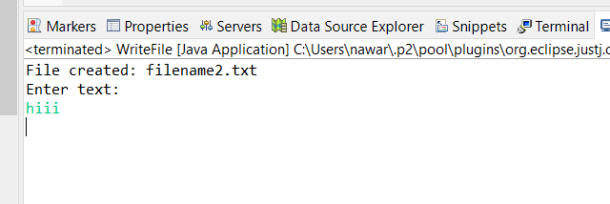

1. WAP to read the content of a file and write it to another file.

**Source code:**

**package** Lab2;

///question 5

**import** java.io.*;

**import** java.util.Scanner;

**public** **class** ReadAndWriteAnother {

**public** **static** **void** main(String[] args) **throws** IOException {

// **TODO** Auto-generated method stub

String pathRead="C:\\Users\\nawar\\OneDrive\\Documents\\Eclipse_JAVA\\College_Lab_Report\\bin\\Lab2\\filename2.txt";

String pathWrite="C:\\Users\\nawar\\OneDrive\\Documents\\Eclipse_JAVA\\College_Lab_Report\\bin\\Lab2\\filename3.txt";

FileWriter fw;

File file= **new** File(pathRead);

Scanner sc = **new** Scanner(file);

**while**(sc.hasNextLine()) {

String data = sc.nextLine();

System.***out***.println(data);

fw= **new** FileWriter(pathWrite);

fw.write(data);

fw.close();

}

System.***out***.println("____________________");

File file2= **new** File(pathWrite);

Scanner sc2 = **new** Scanner(file2);

**while**(sc2.hasNextLine()) {

String data= sc2.nextLine();

System.***out***.println(data);

}

sc.close();

}

}

**Output:**

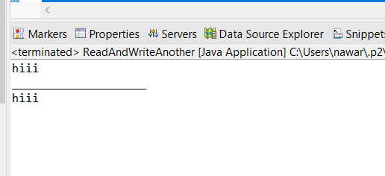

1. Design a simple registration form using swing components. (Form should include textfield, password field, radio button, check box, combo box, image, and text area. Following form is just for your reference!)

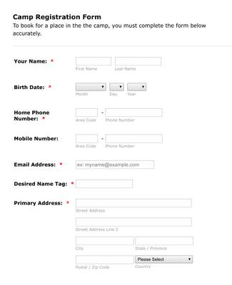

**Source code:**

**package** Lab2;

**import** javax.swing.*;

**import** java.awt.*;

**import** java.awt.event.ActionEvent;

**import** java.awt.event.ActionListener;

**public** **class** RegistrationForm {

**public** **static** **void** main(String[] args) {

// Create the main frame

JFrame frame = **new** JFrame("Registration Form");

frame.setSize(400, 500);

frame.setDefaultCloseOperation(JFrame.***EXIT_ON_CLOSE***);

// Create a panel for the form

JPanel formPanel = **new** JPanel();

formPanel.setLayout(**new** GridLayout(8, 2, 10, 10));

// Add components to the form

formPanel.add(**new** JLabel("Username:"));

JTextField usernameField = **new** JTextField();

formPanel.add(usernameField);

formPanel.add(**new** JLabel("Password:"));

JPasswordField passwordField = **new** JPasswordField();

formPanel.add(passwordField);

formPanel.add(**new** JLabel("Gender:"));

JRadioButton maleRadioButton = **new** JRadioButton("Male");

JRadioButton femaleRadioButton = **new** JRadioButton("Female");

ButtonGroup genderGroup = **new** ButtonGroup();

genderGroup.add(maleRadioButton);

genderGroup.add(femaleRadioButton);

JPanel genderPanel = **new** JPanel();

genderPanel.add(maleRadioButton);

genderPanel.add(femaleRadioButton);

formPanel.add(genderPanel);

formPanel.add(**new** JLabel("Interests:"));

JCheckBox javaCheckBox = **new** JCheckBox("Java");

JCheckBox pythonCheckBox = **new** JCheckBox("Python");

JPanel interestsPanel = **new** JPanel();

interestsPanel.add(javaCheckBox);

interestsPanel.add(pythonCheckBox);

formPanel.add(interestsPanel);

formPanel.add(**new** JLabel("Country:"));

String[] countries = {"Select", "USA", "Canada", "UK", "Australia"};

JComboBox<String> countryComboBox = **new** JComboBox<>(countries);

formPanel.add(countryComboBox);

formPanel.add(**new** JLabel("Profile Picture:"));

ImageIcon defaultImage = **new** ImageIcon("default_profile.png"); // Provide a path to your image

JLabel imageLabel = **new** JLabel(defaultImage);

formPanel.add(imageLabel);

formPanel.add(**new** JLabel("About Me:"));

JTextArea aboutMeTextArea = **new** JTextArea();

JScrollPane scrollPane = **new** JScrollPane(aboutMeTextArea);

formPanel.add(scrollPane);

// Create a button to submit the form

JButton submitButton = **new** JButton("Submit");

submitButton.addActionListener(**new** ActionListener() {

@Override

**public** **void** actionPerformed(ActionEvent e) {

// You can handle form submission logic here

JOptionPane.*showMessageDialog*(frame, "Form submitted successfully!");

}

});

// Add the form panel and submit button to the main frame

frame.setLayout(**new** BorderLayout());

frame.add(formPanel, BorderLayout.***CENTER***);

frame.add(submitButton, BorderLayout.***SOUTH***);

// Set frame visibility

frame.setVisible(**true**);

}

}

**Output:**

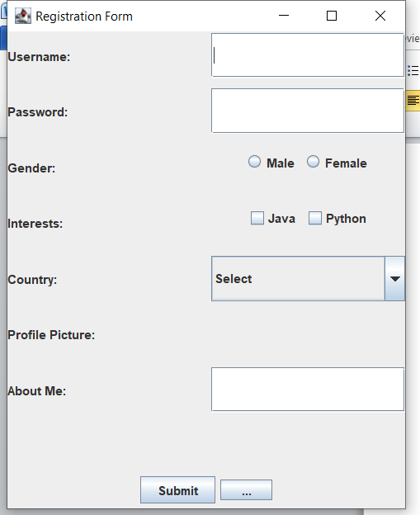

1. Design a simple calculator using GUI components (pick and drop). Calculator must perform at least all the arithmetic operations and reset option).

**Source code:**

**package** Lab2;

**import** java.awt.event.ActionEvent;

**import** java.awt.event.ActionListener;

**import** javax.swing.JButton;

**import** javax.swing.JFrame;

**import** javax.swing.JLabel;

**import** javax.swing.JTextField;

**public** **class** Question7 {

**public** JFrame frame;

**public** JTextField textField;

**public** JTextField textField_1;

**public** JLabel resultLabel;

**public** JLabel lblNewLabel_2;

**public** JLabel lblNewLabel_3;

**public** **double** num1, num2, result;

**public** **char** op;

**private** JTextField textField_2;

**public** **static** **void** main(String[] args) {

// **TODO** Auto-generated method stub

Question7 n = **new** Question7();

}

**public** Question7() {

initialize();

frame.setVisible(**true**);

}

**private** **void** initialize() {

frame = **new** JFrame();

frame.setBounds(100, 100, 401, 208);

frame.setDefaultCloseOperation(JFrame.***EXIT_ON_CLOSE***);

frame.getContentPane().setLayout(**null**);

textField = **new** JTextField();

textField.setBounds(216, 10, 133, 19);

frame.getContentPane().add(textField);

textField.setColumns(10);

textField_1 = **new** JTextField();

textField_1.setBounds(216, 50, 133, 19);

frame.getContentPane().add(textField_1);

textField_1.setColumns(10);

JLabel lblNewLabel = **new** JLabel("Enter value: ");

lblNewLabel.setBounds(32, 13, 100, 13);

frame.getContentPane().add(lblNewLabel);

JLabel lblNewLabel_1 = **new** JLabel("Enter value: ");

lblNewLabel_1.setBounds(32, 53, 100, 13);

frame.getContentPane().add(lblNewLabel_1);

lblNewLabel_2 = **new** JLabel("Result: ");

lblNewLabel_2.setBounds(37, 130, 95, 13);

frame.getContentPane().add(lblNewLabel_2);

resultLabel = **new** JLabel("");

resultLabel.setBounds(154, 130, 133, 13);

frame.getContentPane().add(resultLabel);

JButton btnNewButton = **new** JButton("Action");

btnNewButton.addActionListener(**new** ActionListener() {

**public** **void** actionPerformed(ActionEvent e) {

performAction();

}

});

btnNewButton.setBounds(154, 126, 85, 21);

frame.getContentPane().add(btnNewButton);

JButton btnNewButton_1 = **new** JButton("Reset");

btnNewButton_1.addActionListener(**new** ActionListener() {

**public** **void** actionPerformed(ActionEvent e) {

reset();

}

});

btnNewButton_1.setBounds(292, 126, 85, 21);

frame.getContentPane().add(btnNewButton_1);

lblNewLabel_3 = **new** JLabel("Enter operator\n" + "+,-,*,/");

lblNewLabel_3.setBounds(32, 86, 150, 13);

frame.getContentPane().add(lblNewLabel_3);

textField_2 = **new** JTextField();

textField_2.setBounds(216, 79, 133, 19);

frame.getContentPane().add(textField_2);

textField_2.setColumns(10);

}

**private** **void** performAction() {

String a = textField_2.getText();

op = a.charAt(0);

**try** {

num1 = Double.*parseDouble*(textField.getText());

num2 = Double.*parseDouble*(textField_1.getText());

**switch** (op) {

**case** '+':

result = num1 + num2;

**break**;

**case** '-':

result = num1 - num2;

**break**;

**case** '*':

result = num1 * num2;

**break**;

**case** '/':

**if** (num2 != 0) {

result = num1 / num2;

} **else** {

lblNewLabel_2.setText("Error");

**return**;

}

**break**;

}

lblNewLabel_2.setText("Result: " + result);

} **catch** (NumberFormatException ex) {

resultLabel.setText("Invalid input");

}

}

**private** **void** reset() {

textField.setText("");

textField_1.setText("");

lblNewLabel_2.setText("Result: ");

textField_2.setText("");

num1 = 0;

num2 = 0;

result = 0;

op = '\0';

}

}

**Output:**

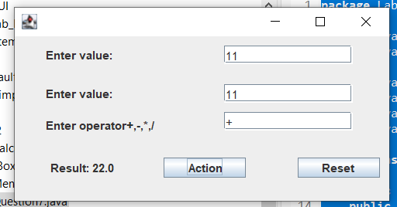

1. WAP to implement different dialog boxes.

**Source code:**

**package** Lab2;

//question 8

**import** javax.swing.JOptionPane;

**public** **class** JBox {

**public** **static** **void** main(String[] args) {

// **TODO** Auto-generated method stub

JOptionPane.*showMessageDialog*(**null**, "Welcome to my page");

String name=JOptionPane.*showInputDialog*(**null**, "What's your name!!");

String age=JOptionPane.*showInputDialog*(**null**, "What's your age!!");

**int** real_age= Integer.*parseInt*(age);

JOptionPane.*showMessageDialog*(**null**, "Hi,"+real_age+"years old "+name);

**int** choice=JOptionPane.*showConfirmDialog*(**null**, "Do you like cakes? "+name);

// System.out.println(choice);

**if**(choice==JOptionPane.***YES_OPTION***) {

JOptionPane.*showMessageDialog*(**null**, "Thank you !!");

}**else** **if**(choice==JOptionPane.***NO_OPTION***) {

JOptionPane.*showMessageDialog*(**null**, "Im sad!!");

}

**else** **if**(choice==JOptionPane.***CANCEL_OPTION***) {

JOptionPane.*showMessageDialog*(**null**, "You can try again");

}

}

}

**Output:**

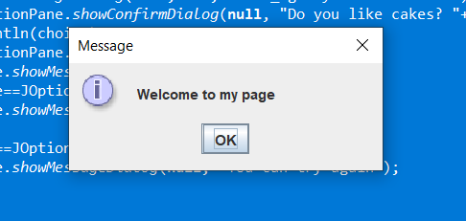

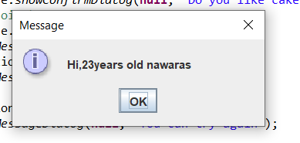

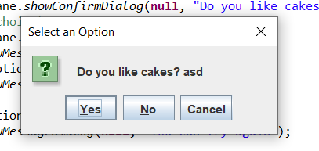

1. WAP to implement menu and popup menu option in Java.

**Source code:**

**package** Lab2;

**import** javax.swing.*;

**import** java.awt.*;

**import** java.awt.event.ActionEvent;

**import** java.awt.event.ActionListener;

**public** **class** MenuExample {

**public** MenuExample() {

JFrame frame = **new** JFrame("PopupMenu Example");

// Create a popup menu

JPopupMenu popupMenu = **new** JPopupMenu("Edit");

// Create menu items

JMenuItem cut = **new** JMenuItem("Cut");

cut.setActionCommand("Cut");

JMenuItem copy = **new** JMenuItem("Copy");

copy.setActionCommand("Copy");

JMenuItem paste = **new** JMenuItem("Paste");

paste.setActionCommand("Paste");

// Add menu items to the popup menu

popupMenu.add(cut);

popupMenu.add(copy);

popupMenu.add(paste);

// Add action listeners to menu items

cut.addActionListener(**new** ActionListener() {

@Override

**public** **void** actionPerformed(ActionEvent e) {

JOptionPane.*showMessageDialog*(frame, "Cut action performed");

}

});

copy.addActionListener(**new** ActionListener() {

@Override

**public** **void** actionPerformed(ActionEvent e) {

JOptionPane.*showMessageDialog*(frame, "Copy action performed");

}

});

paste.addActionListener(**new** ActionListener() {

@Override

**public** **void** actionPerformed(ActionEvent e) {

JOptionPane.*showMessageDialog*(frame, "Paste action performed");

}

});

// Add a dummy component to the frame to trigger the popup menu

JButton dummyButton = **new** JButton("Right-click here");

dummyButton.setComponentPopupMenu(popupMenu);

// Use a layout manager (FlowLayout in this case)

frame.setLayout(**new** FlowLayout());

frame.add(dummyButton);

frame.setSize(400, 300);

frame.setDefaultCloseOperation(JFrame.***EXIT_ON_CLOSE***);

frame.setVisible(**true**);

}

**public** **static** **void** main(String args[]) {

SwingUtilities.*invokeLater*(() -> **new** MenuExample());

}

}

**Output:**

